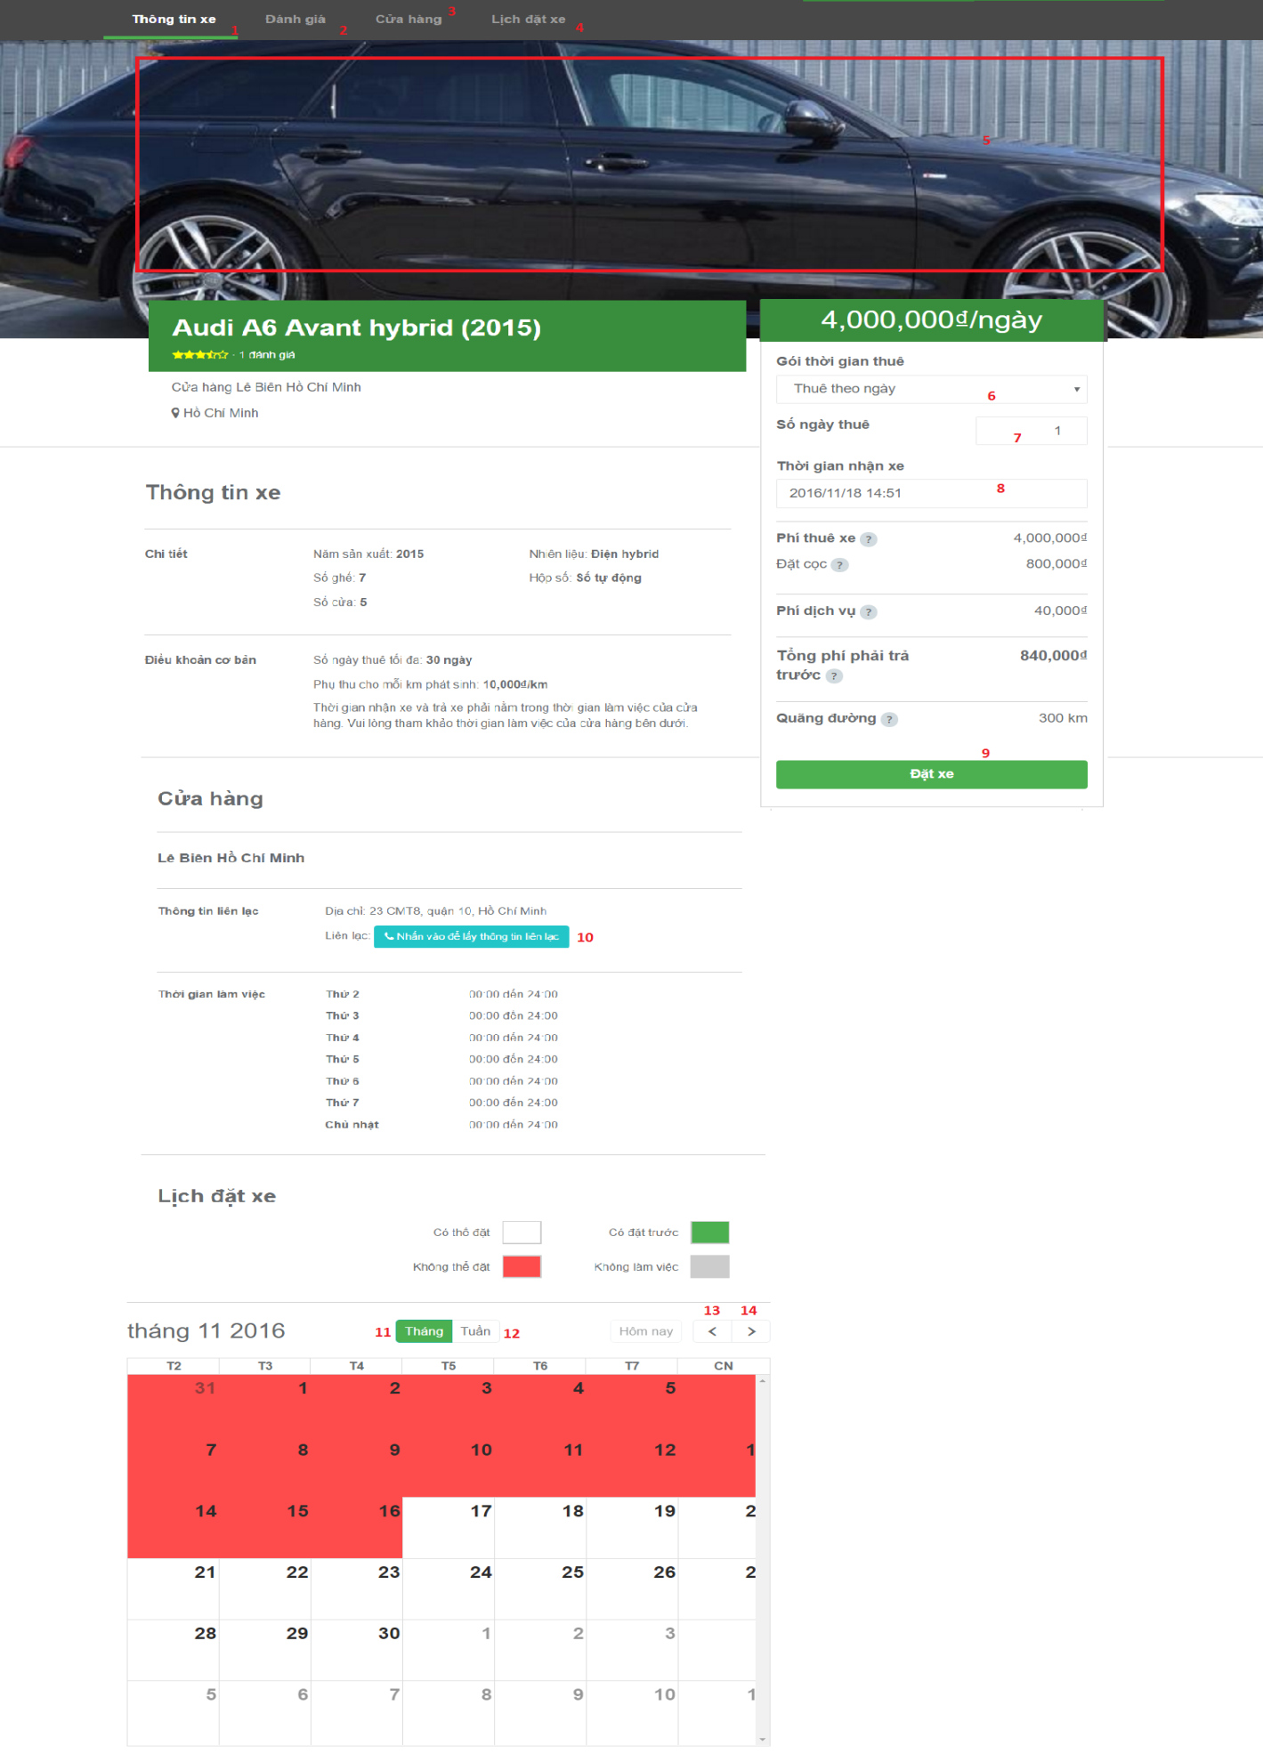

**Fields:**

|  |  |  |  |  |  |  |
| --- | --- | --- | --- | --- | --- | --- |
| No | Field Name | Description | Read Only | Mandatory | Control Type | Data Type |
| 6 | Type rent vehicle | Choose type rent vehicle, such as day or hour | Yes | Yes | Drop down list | String |
| 7 | Number day/hour for rent | Input time will rent vehicle | No | Yes | Text box | Number |
| 8 | Date will pick up vehicle | Input date and time will pick up vehicle | No | Yes | Text Box | Date time |

**Buttons/Hyperlinks:**

|  |  |  |  |  |
| --- | --- | --- | --- | --- |
| No | Function | Description | Validation | Outcome |
| 1 | Moving main screen view to information of vehicle area | Main screen view switch to information of vehicle area. | N/A | Main screen view switch to information of vehicle area. |
| 2 | Moving main screen view to comment area | Main screen view to comment area. | N/A | Main screen view to comment area. |
| 3 | Moving main screen view to garage area | Main screen view to garage area. | N/A | Main screen view to garage area. |
| 4 | Moving main screen view to booking history area | Main screen view to booking history area. | N/A | Main screen view to booking history area. |
| 5 | View images of vehicle | View all images of vehicle | N/A | Show all images of vehicle |
| 9 | Booking request command | Send booking information to controller | N/A | Redirect to booking confirm page. |
| 10 | Show information of garage in detail | Show information of garage | N/A | Show pop up information of garage |
| 11 | Filter calendar view with month | Calendar of booking will represented by month | N/A | Calendar of booking will represented by month |
| 12 | Filter calendar view with week | Calendar of booking will represented by week |  | Calendar of booking will represented by week |
| 9 | Show Previous data of Calendar | Show previous data of calendar | N/A | Show previous data of calendar |
| 11 | Show Next data of Calendar | Show next data of calendar record of table | N/A | Show next data of calendar |